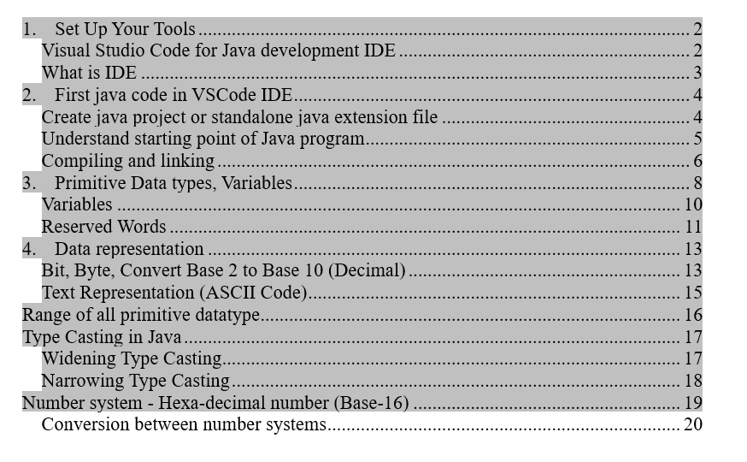

Online tutorials for self-study
- Java for Beginners complete 2 hours tutorial: https://www.youtube.com/watch?v=o33cQL6-2Sg&t=19s
Udemy Learning Platform
- https://www.udemy.com/courses/search/?src=ukw&q=java+tutorials

